**THE BRAIDY BUNCH: Easy Braided Hairstyles for Summer**

From Frozen to Game of Thrones to the red carpet, braids are the hair style this season. Here are five not-so-plain plaits to add some fun into your everyday look.

By Michele Meyer

Life & Beauty Weekly Contributing Beauty/Fashion Writer

[by**lifeandbeauty**](https://lifeandbeautyweekly.com/author/lifeandbeauty/)

May 15, 2014

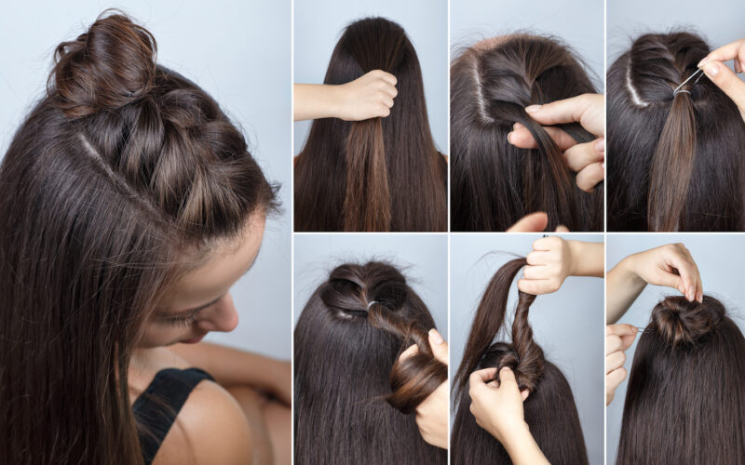

This summer’s hottest hairstyle is the braid — and not just because a cool swept-away style beats having your hair sweat-plastered to your neck. “Braids are having a moment, because there are so many different types — and can be done yourself quickly without heat or styling tools,” says Jeanie Syfu, TRESemmé’s lead stylist. Weaving your hair is calming and therapeutic, says model stylist Matt Fugate. “I find it enhances creativity, too.”

Best of all, anyone can do it — and if it comes out a little messy, so much the better! Here are some easy braided hairstyles that are hot this summer along with plait pro tips for mastering each style:

**What: Beach Fishtail**

**Where**: Jessica Lowndes, *Downton Abbey*’s Michele Dockery and *Frozen*princesses Elsa and Anna

**How**: Split shoulder-length or beyond hair into two sections. Take a little hair from the outside of one section and cross it over. Do the same with the outer strands of the other portion. Repeat. The looser the braiding, the more modern it looks. Wrap the bottom with a clear band. For a more glamorous look, start with a high ponytail. Or sneak in a hair treatment by working leave-in conditioner into towel-dried hair before braiding.

**What: Side Braid**

**Where**: Brooke Lively and Valentino’s Fall 2013 models

**How**: Part hair in the middle or to the far side. Pull hair to one side in a ponytail that starts at your nape. Start braiding. Pull out some tufts.

**What: Braid-y Bunches**

**Where**: Socialite Nicky Hilton at Coachella and Maria Menounos at the Oscars

**How**:  Pull hair tightly into pigtails just to each side of the nape, then braid. Use an elastic at the tails’ ends, then wind into a bun. For a looser version, start with a side part, with thick braids starting at the hairline on each side of the part. Add to the section as you move back and down the head behind the ears, with the braid getting looser as you descend. Roll braid into a bun at the nape of the neck.

**What: Boldi-Locks**

**Where**: Vanessa Hutchens at Coachella

**How**: Split hair into six small sections, then weave from the middle down. Moisten pastel hair chalk, and coat the surface of one section moving down the plait for a temporary but fun funky look, suggests Edward Tricomi, stylist and co-owner of Warren-Tricomi Salons.

**What: Halo**

**Where**: 20th Century artist Frida Kahlo and Sarah Hyland at the 2014 Golden Globes

**How**: Towel-dry hair. Create a side part and, if you can, a zigzag part. Start with two ponytails, low at the nape of your neck. Divide ponytails into three or four sections and braid to end. Loosen, then wrap around your head behind the ears and tuck hair under the braids and fasten with hair pins.

**What: Boho Braids**

**Where**: Rodarte runway Fall 2013 and on the women of *Game of Thrones*

**How**: Part hair in the center,  
either straight or with a zigzag. Take a small piece of hair at the temple and  
braid halfway before tying with an elastic. Do the same at the other temple.  
Join the two plaits at the back, perhaps winding one into a chignon where they  
meet. Or go loose, as seen at Victor & Rolf’s Fall 2014 runway: Take a  
section of hair just above each ear. Halfway down, weave them together twice,  
pin in place, and leave the rest hanging.

[Share](https://www.facebook.com/sharer.php?u=https://lifeandbeautyweekly.com/2014/05/easy-braided-hairstyles-summer/)